

Submitted by: Iram Mehboob
Submitted to: Mam Nayab Khalid
Sap id: 73644

Task 01:

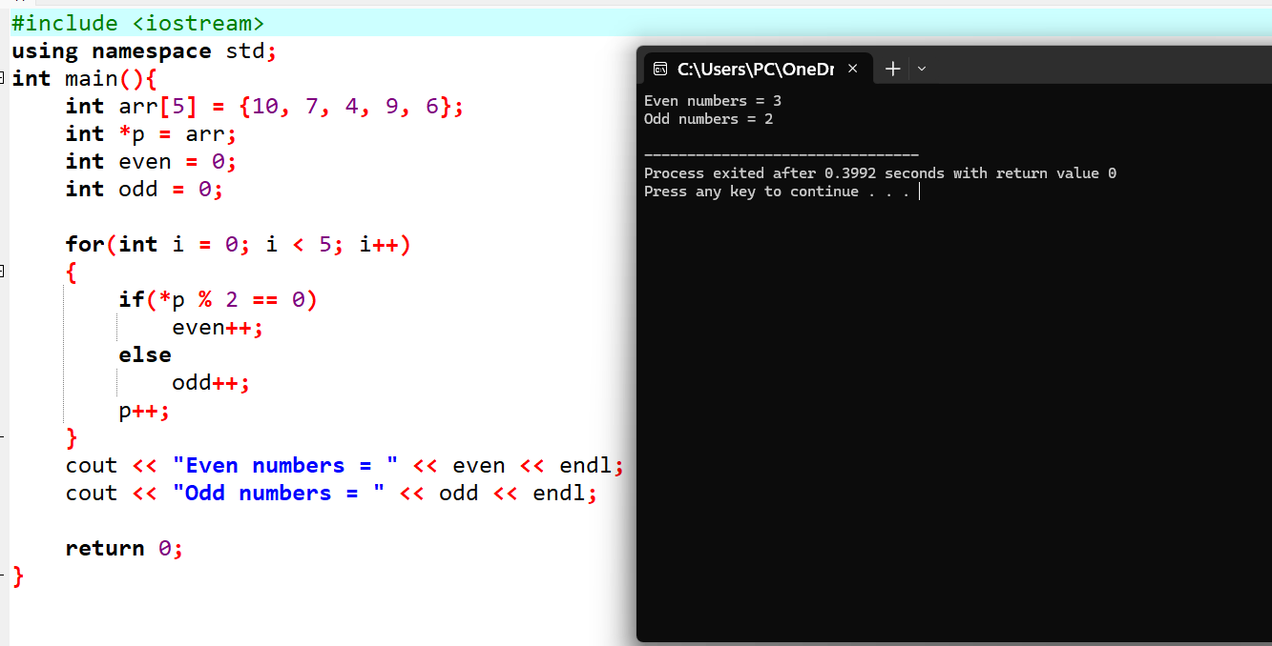
Task 2:
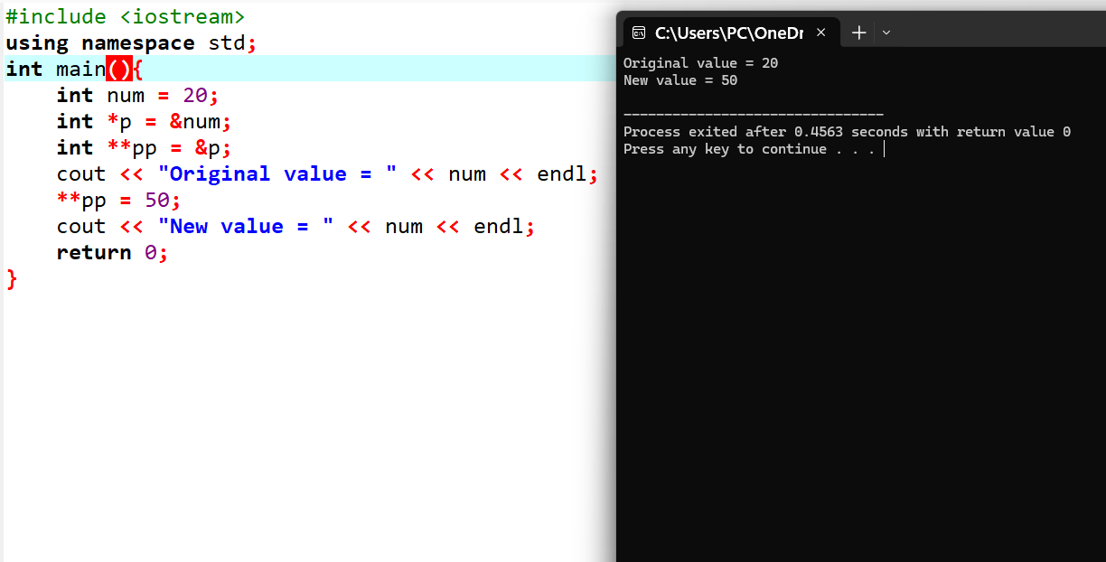

Task 3:


